Sean Parrell

9/29/2024

R assignment 2

All of this is screenshots from my code and format from within R

Exercise 4.1We are given a vector c(6,9,7,3,6,7,9,6,3,6,6,7,1,9,1) and tasked with performing multiple operations on it.Part (a) – Identify elements of the vector for the following conditions:

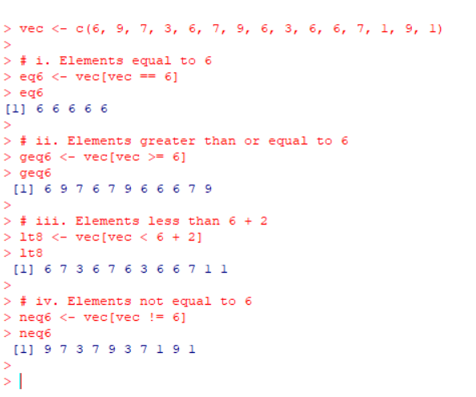

Part (b) – Create a new vector by removing the first three elements and filling it into a 2 x 2 x 3 array.

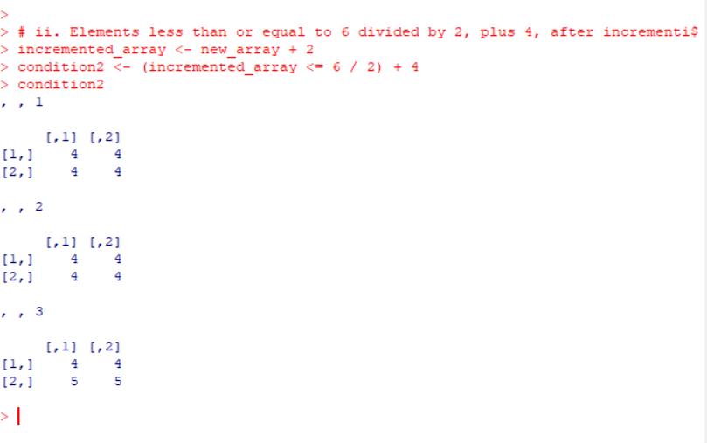

Part (c) – Confirm locations of elements equal to 0 in the 10 x 10 identity matrix.

I10 <- diag(10)

> zeros <- which(I10 == 0, arr.ind = TRUE)

> zeros

row col

[1,] 2 1

[2,] 3 1

[3,] 4 1

[4,] 5 1

[5,] 6 1

[6,] 7 1

[7,] 8 1

[8,] 9 1

[9,] 10 1

[10,] 1 2

[11,] 3 2

[12,] 4 2

[13,] 5 2

[14,] 6 2

[15,] 7 2

[16,] 8 2

[17,] 9 2

[18,] 10 2

[19,] 1 3

[20,] 2 3

[21,] 4 3

[22,] 5 3

[23,] 6 3

[24,] 7 3

[25,] 8 3

[26,] 9 3

[27,] 10 3

[28,] 1 4

[29,] 2 4

[30,] 3 4

[31,] 5 4

[32,] 6 4

[33,] 7 4

[34,] 8 4

[35,] 9 4

[36,] 10 4

[37,] 1 5

[38,] 2 5

[39,] 3 5

[40,] 4 5

[41,] 6 5

[42,] 7 5

[43,] 8 5

[44,] 9 5

[45,] 10 5

[46,] 1 6

[47,] 2 6

[48,] 3 6

[49,] 4 6

[50,] 5 6

[51,] 7 6

[52,] 8 6

[53,] 9 6

[54,] 10 6

[55,] 1 7

[56,] 2 7

[57,] 3 7

[58,] 4 7

[59,] 5 7

[60,] 6 7

[61,] 8 7

[62,] 9 7

[63,] 10 7

[64,] 1 8

[65,] 2 8

[66,] 3 8

[67,] 4 8

[68,] 5 8

[69,] 6 8

[70,] 7 8

[71,] 9 8

[72,] 10 8

[73,] 1 9

[74,] 2 9

[75,] 3 9

[76,] 4 9

[77,] 5 9

[78,] 6 9

[79,] 7 9

[80,] 8 9

[81,] 10 9

[82,] 1 10

[83,] 2 10

[84,] 3 10

[85,] 4 10

[86,] 5 10

[87,] 6 10

[88,] 7 10

[89,] 8 10

[90,] 9 10

>

Part (d) – Check if any and all of the conditions in part (b) are true.

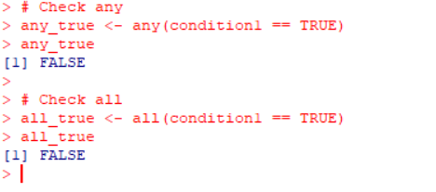

Part (e) – Extract diagonal elements from the matrix in part (c) and check if they are all TRUE.

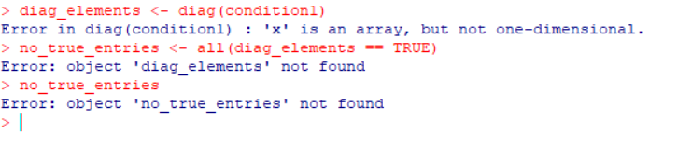

Exercise 16.2This problem involves a Poisson distribution where the average number of cars passing by is 107.Part (a) – Find the probability that more than 100 cars pass on a given Saturday.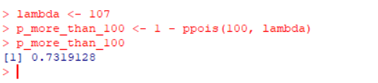

Part (b) – Determine the probability that no cars pass.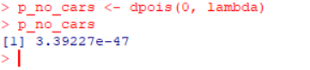

Part (c) – Plot the Poisson mass function for 60 ≤ x ≤ 150.

